1. Given five memory partitions of 100KB, 500KB, 200KB, 300KB, and 600KB (in order), how would each of the first-fit, best-fit, and worst-fit algorithms place processes of 212KB, 417KB, 112KB, and 426KB (in order)? Which algorithm makes the most efficient use of memory?

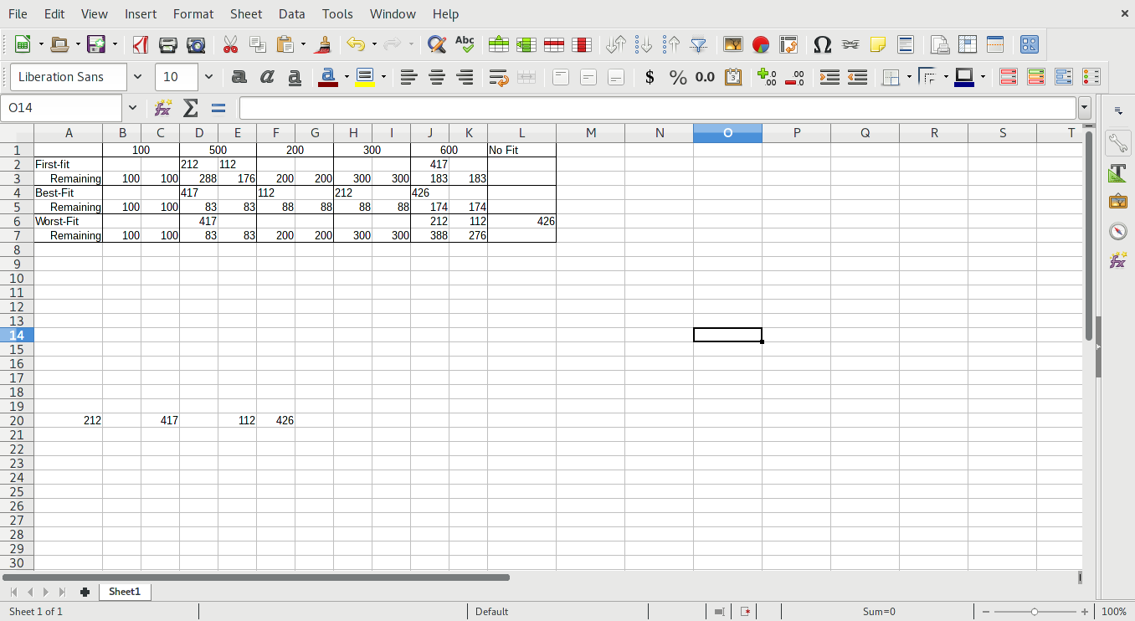

By design, the Best-Fit Algorithm makes the most efficient use of memory.

1. Explain why implementing synchronization primitives by disabling interrupts is not appropriate in a single-processor system if the synchronization primitives are to be used in user-level programs.

If a user-level program can disable interrupts it can disable timer interrupts to prevent context switching and lock the system up.

1. Consider the following situation where there are two processes, P0 and P1, each accessing two semaphores S and Q and initially set the value 1: Will there be a deadlock? If so, modify the code to be a deadlock free.

|  |  |
| --- | --- |
| P0 | P1 |
| Signal(Q) | Signal(S) |
| Wait(S) | Wait(Q) |
| . | . |
| . | . |
| Signal(S) | Signal(Q) |
| Wait(Q) | Wait(S) |

1. Consider the deadlock situation that could occur in the dining-philosophers problem when the philosophers obtain the chopsticks one at a time. Discuss how the four necessary conditions for deadlock indeed hold in this setting. Discuss how deadlocks could be avoided by eliminating any one of the four conditions.

Mutual exclusion: only a single philosopher can use a chopstick at once.

Hold and wait: Each philosopher picks up a chopstick and waits to get another.

No preemption: No philosopher will drop their chopstick until they finish eating.

Circular wait: Each philosopher is waiting for the chopstick on one side, but has the chopstick on the other held, meaning the philosopher to the opposite side cannot pick up the held chopstick.

1. Consider the following resource-allocation graph, identify whether there is a deadlock or not and explain why

No, the graph cannot result in a deadlock because there is more than one instance for each resource type.

1. Compare the main memory organization schemes of contiguous-memory allocation, and pure paging with respect to the following issues:
   1. External fragmentation
   2. internal fragmentation

Contiguous-memory allocation creates a number of contiguous partitions in memory, with leftover space in between processes, creating external fragmentation. Pure paging creates internal fragmentation because the program is stored in logical memory that is used to translate into physical memory, but the page file must also be stored.

1. Describe how VFS handle handing underline implementation of the various file systems including devices.

The VSF uses the linux kernel and it’s driver routines to open, read, and write to various file system.